LAB#10

UNSUPERVISED LEARNING ALGORITHMS

Perform unsupervised learning K-means clustering algorithm for training, testing and classification using Python.

Unsupervised Learning
Algorithms belonging to the family of Unsupervised Learning have no variable to predict tied to the data. Instead of having an output, the data only has an input which would be multiple variables that describe the data. This is where clustering comes in. Clustering is the task of grouping together a set of objects in a way that objects in the same cluster are more similar to each other than to objects in other clusters. Similarity is a metric that reflects the strength of relationship between two data objects. Clustering is mainly used for exploratory data mining. It has manifold usage in many fields such as machine learning, pattern recognition, image analysis, information retrieval, bio-informatics, data compression, and computer graphics.

K-Means Clustering
K-Means falls under the category of centroid-based clustering. A centroid is a data point (imaginary or real) at the center of a cluster. In centroid-based clustering, clusters are represented by a central vector or a centroid. This centroid might not necessarily be a member of the dataset. Centroid-based clustering is an iterative algorithm in which the notion of similarity is derived by how close a data point is to the centroid of the cluster.
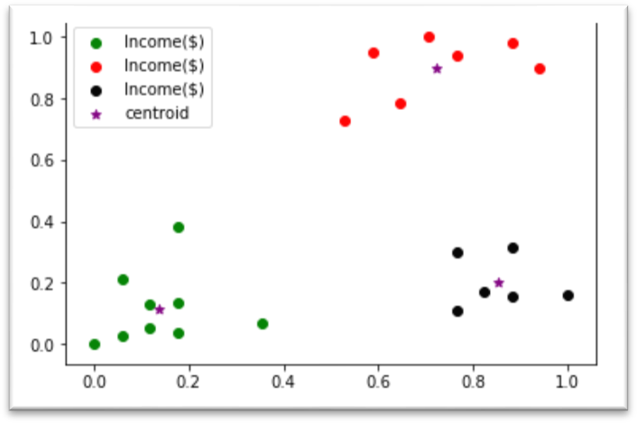
Figure 10.1 Distribution of dataset into three clusters through K-Means Clustering

K-means clustering is one of the most widely used unsupervised machine learning algorithms that forms clusters of data based on the similarity between data instances. For this particular algorithm to work, the number of clusters has to be defined beforehand. The K in the K-means refers to the number of clusters.

The K-means algorithm starts by randomly choosing a centroid value for each cluster. After that the algorithm iteratively performs three steps:
  - Find the Euclidean distance between each data instance and centroids of all the clusters.
  - Assign the data instances to the cluster of the centroid with nearest distance.
  - Calculate new centroid values based on the mean values of the coordinates of all the data instances from the corresponding cluster.

Disadvantages of K-Means:

The biggest disadvantage is that K-Means Clustering Algorithm requires you to pre-specify the number of clusters (k). Hierarchical clustering is an alternative approach that does not require a particular choice of clusters. An additional disadvantage of k-means is that it is sensitive to outliers and different results can occur if you change the ordering of the data.

K-Means is a lazy learner where generalization of the training data is delayed until a query is made to the system. This means K-Means starts working only when you trigger it to, thus lazy learning methods can construct a different approximation or result to the target function for each encountered query. It is a good method for online learning, but it requires a possibly large amount of memory to store the data, and each request involves starting the identification of a local model from scratch.

Pseudo code for K-Means Clustering:
  - Import the required libraries. from sklearn.cluster import KMeans import pandas as pd
from sklearn.preprocessing import MinMaxScaler
#(if you want to perform preprocessing on your dataset).
  - Load the csv file and construct the data frame.
  - Apply K-Means Algorithm. km = KMeans(n_clusters=3)
    - Fit the dataset.
y_predicted = km.fit_predict(df[['Age','Income($)']]) print(y_predicted)
This will show the clusters, assigned to each data point.
    - Add these cluster assignments in the form of a new column ‘cluster’ to your dataframe.
df['cluster']=y_predicted
    - In order to find out cluster centres, use print(km.cluster_centers_)

Activity- 1:
Consider the dataset given below, implement K-Means Clustering algorithm using K=2. Find out new centroid values based on the mean values of the coordinates of all the data instances from the corresponding cluster. Also find the accuracy of the model and compute it manually.

S. No. | A | B
1 | 170 | 56
2 | 168 | 60
3 | 185 | 72
4 | 188 | 77
5 | 177 | 76
6 | 180 | 71

Activity- 2:
A dataset (income.csv) has been provided. Implement K-Means Clustering Algorithm on this dataset using K (number of clusters = 3). Find out new centroid values based on the mean values of the coordinates of all the data instances from the corresponding cluster. Also find the accuracy of the model.

Activity- 3:
A dataset (ratings_small.csv) has been provided. Implement K-Means Clustering Algorithm on this dataset using K (number of clusters = 5). Find out new centroid values based on the mean values of the coordinates of all the data instances from the corresponding cluster. Also find the accuracy of the model.

